**Project Name:** College ERP

**Github Link:** https://github.com/projectsforstudents2022/College-ERP.git

**Why was this project created?**

A college is made up of many departments, such as those in charge of courses, fee administration, the library, event planning, etc. Since there are more applications and uses of information technology today than there were in the past, each of these distinct departments has its own computer system to carry out its own functions. Having a single core system allows them to communicate with one another from their own systems with a working username and password.

**What problem is it solving?**

This project's major goal is to demonstrate how the College Information Management System's standards should be met. It is designed to assist any business in maintaining and managing personal data. It is an extensive undertaking that was created from the bottom up to meet the demands of universities as they mentor their students. The daily activities in the college environment are connected by this integrated information management system, from attendance control to means of communication between students and teachers. This minimizes data inaccuracy and guarantees that all of the college's information is constantly current.

**Entire explanation of project**

* **PROPOSED APPROACH**

The administrator gives each college student a special username and password. Both the user name and the password are the same as their USN. They have the option to modify it at a later time. The student is given a homepage containing their primary sections, attendance, grades, and schedule after successfully logging in. The student can examine their attendance status, which includes the number of total classes, classes attended, and the attendance % for each of their courses, under the attendance area. There is a list of classes that are dependent on each student on the attendance page. Along with the number of attended classes, the total number of classes, and the attendance % for each course, the course id and name are also displayed.

Each of their courses has an entry on the Marks page, which is a table. Along with the grades earned on each test and exam are the course ID and name. The administrator gives each college teacher a special login and password. Their teacher ID serves as both the username and password. Later, the instructor might alter the password. The student is given a homepage with their primary sections, attendance, grades, a schedule, and reports after successfully logging in. The teacher can edit attendance after entering it. Similar to the screen used to record attendance, with the exception that the recorded attendance is saved and displayed. The teacher gets access to the list of students and the grades they received for each allocated class.

* **RESULT**

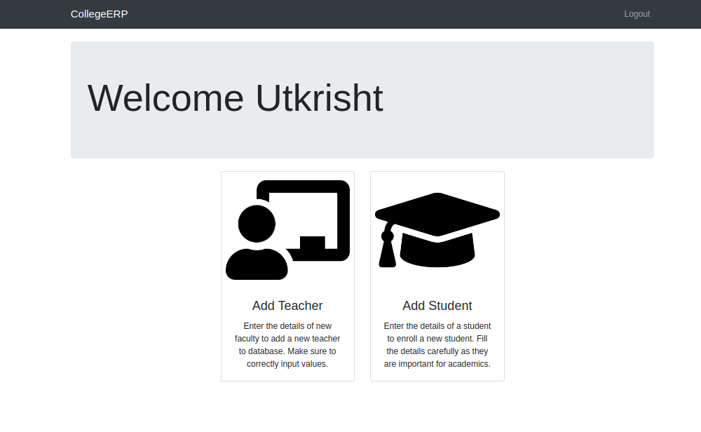

**CONCLUSION**

Based on their profiles and roles within the system, the college ERP gives users the pertinent information. This project was created with the day-to-day issues that a college system faces in mind. Thus, the basic issue with the administrator's ability to maintain and manage their work is resolved. Prior to this, following the schedule and keeping track of the daily tasks was a little challenging. However, by creating this web-based application, the administrator can have pleasure in the activity while easily completing it and while also saving significant time. The user can access the reports on a regular basis and whenever they need them, saving time and eliminating the need for manual calculations.